1. Application Tracker VI : Data is off in Chapter 1( GBS/IT VP). This might be due to the inconsistency of the Grace Period Start Date in Dev instance.

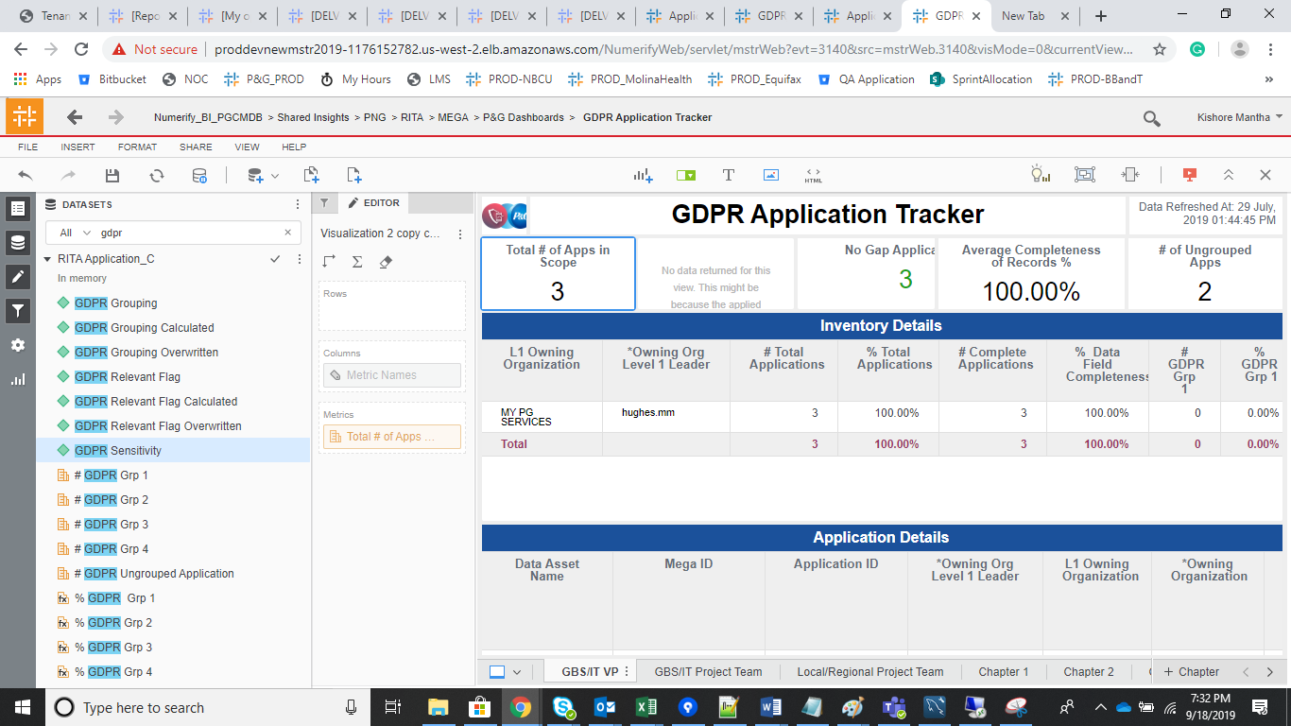

1. ITAM_Application Governance : Data is higher than the PROD instance. This is due to the new filter and data from the Service now.

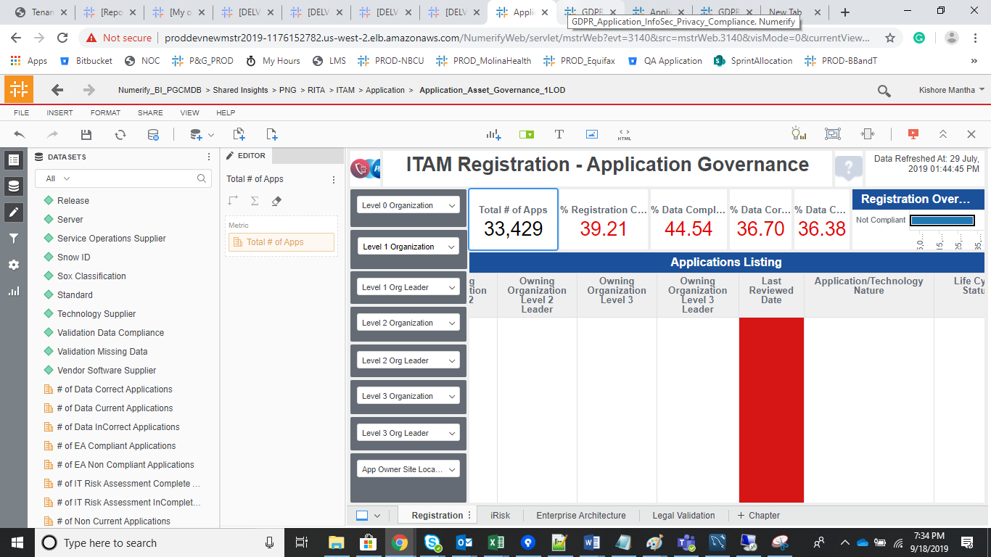

1. GDPR Application infoSec privacy VI :

Data is not populated as expected (Compliance and Category) in the Infosec Report. Will fix it and moved to UAT instance.

